StudentIDs: | 293867 | Score:
Class: | Data Warehouse Mini-Project
Date: | 23-06-2026
This mini project assignment consists of 2 tasks. You should focus on providing complete solution, however if you are unable to solve a particular step, try to give at least a partial solution or provide justification for the reason for the lack of a solution. Please note that quality and scope of the provided solution affect the grade.

Mini-project 4 - Consumption
The focus of this stage is on prepare data consumption for the end users.
You will create a dedicated dashboard for the selected type of user and focusing on a selected aspect of analysis. You can choose the user type and the selected aspect - just make sure that the result (dashboard) is consistent with the goals. The quality and complexity of the dashboard affect your final score.

Task 1 - Model testing
Addressing the identified information needs of users through OLAP queries from Stage 1 of the project. The idea behind this task is to verify how good is your final data model and experience how some design decision affects the information capabilities of the proposed solution. As such, for 10 selected (you must choose 10 from the original queries in Stage 1; if you have prepared less than 10 you must introduce new ones) queries from Stage 1:
- If an answer is possible, present the response in the form of a pivot table/visualization using the developed data model.
- If an answer is not possible, justify why the user’s specific need cannot be addressed with the developed data model.
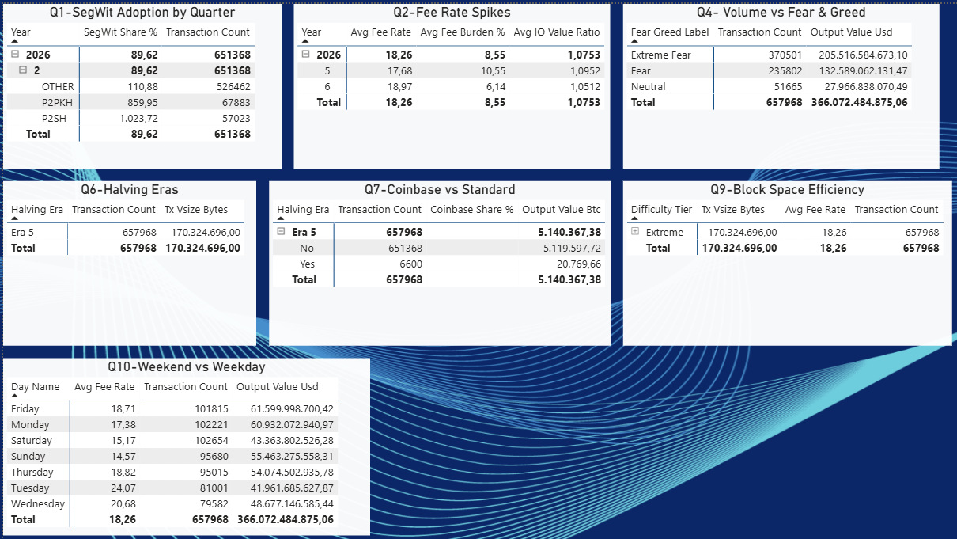
Given the values of the queries in this image (PowerBI: “Questions Part 1”):

1.1 SegWit Adoption Rate Over Time (by Quarter)
Analytical Question: What is the adoption rate of SegWit-native script types (P2WPKH, P2WSH, P2TR) versus legacy types (P2PKH, P2SH), and how has this composition evolved quarter by quarter?
Answer:
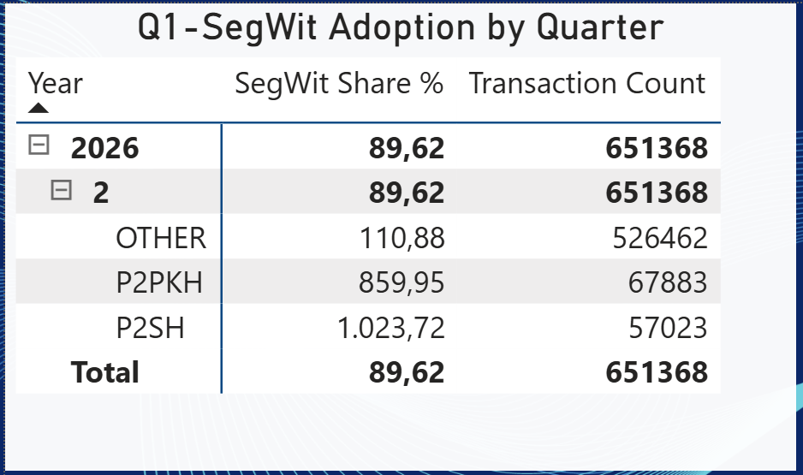
Note: Data covers 2026 Q2 only. SegWit-native share stands at 89.62 % of all 651,368 transactions. P2PKH dominates the legacy segment with 67,883 transactions.

1.2 Fee-Rate Spikes Under Network Congestion
Analytical Question: Under what conditions of network congestion (average transaction weight and size per block) do fee rates (sat/vByte) spike, and how do they correlate with daily market price trends?
Answer:
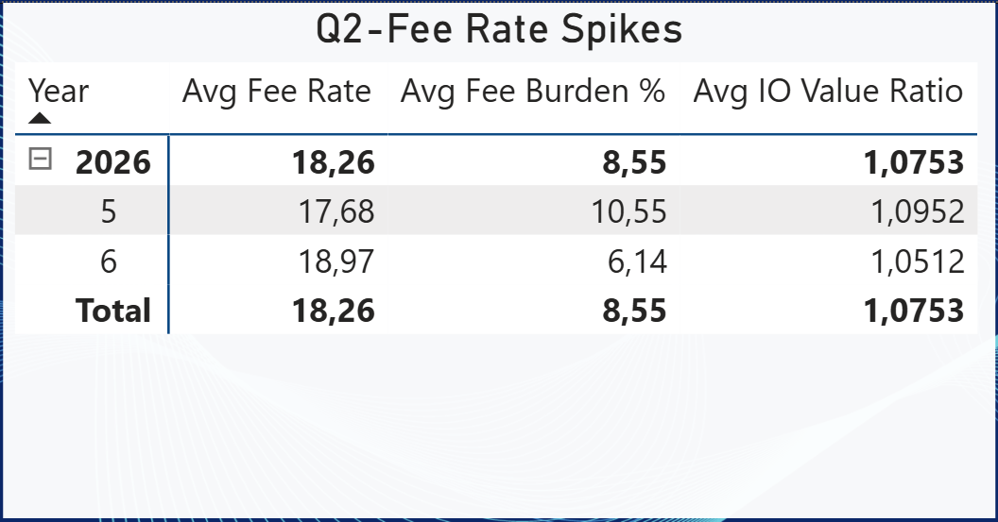
Note: Months 5 and 6 of 2026 are compared. Month 6 shows a higher avg fee rate (18.97) but lower fee burden (6.14 %), suggesting larger-value transactions absorb fees more efficiently. The IO Value Ratio is near parity (~1.05-1.10) across both months.

1.3 Fee Burden Distribution Across Transaction Size Tiers
Analytical Question: What is the distribution of transaction fee burden (fee in USD as a percentage of total output value) across different transaction virtual-size tiers?
Answer:
This query CANNOT be answered with the current data model.

The data model does not include a dedicated 'transaction virtual-size tier' dimension. Grouping transactions into vSize buckets (e.g. <250 vB, 250-1000 vB, >1000 vB) requires either a computed column at ETL time or a DAX calculated-column creating a tier band from the Tx_vsize_bytes measure. Without a persistent size-tier attribute in the fact table or a related dimension, Power BI cannot slice the fee-burden KPI across those buckets in a pivot table. Additionally, fee burden expressed as 'fee in USD as % of total output value' requires both a USD-converted fee column and the total output value column in the same row grain - if output value is only aggregated at block level rather than transaction level, the per-transaction ratio cannot be computed.

1.4 Transaction Volume vs. Fear & Greed Index
Analytical Question: How does daily transaction volume and total settlement value in USD correlate with the daily Fear & Greed Index? Are periods of market greed accompanied by larger transaction values?
Answer:
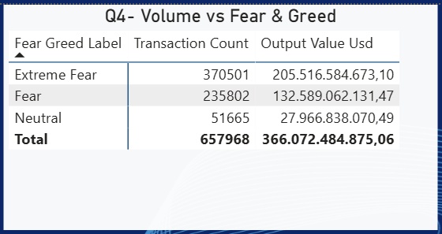
Note: Periods of market fear dominate Bitcoin's on-chain activity. "Extreme Fear" accounts for the largest share with 370,501 transactions and $205.5B in output value, followed by "Fear" with 235,802 transactions and $132.6B. "Neutral" sentiment days show significantly lower activity (51,665 transactions, $28.0B). This suggests that rather than greed driving larger settlement values, Bitcoin on-chain volume is actually highest during fearful market conditions - consistent with panic selling or accumulation behaviour during downturns.

1.5 Multi-Input vs. Single-Input Transaction Structure
Analytical Question: What proportion of transactions use multiple inputs (address consolidation or complex spending patterns) versus single inputs, and how does this vary across legacy versus SegWit script types?
Answer:
This query CANNOT be answered with the current data model.
The data model does not store the number of inputs per individual transaction (input_count at transaction grain). Classifying a transaction as 'single-input' versus 'multi-input' requires a transaction-level attribute (e.g. vin_count). If the fact table only holds aggregated block-level metrics, the input cardinality per transaction is lost during ETL. Furthermore, cross-tabulating this attribute against the script type (P2PKH, P2SH, P2WPKH, etc.) requires both dimensions on the same transaction row. Without this granularity, the pivot table cannot distinguish address-consolidation patterns from simple single-input spends across legacy vs SegWit types.

1.6 Transaction Evolution Across Halving Eras
Analytical Question: How have transaction counts, average transaction sizes (vBytes), and average block density evolved across the four completed Bitcoin halving cycles?
Answer:
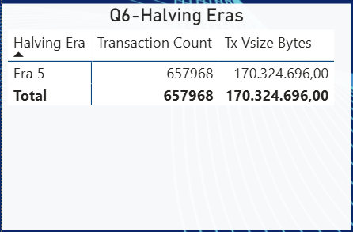
Note: Current data covers Era 5 only (post-4th halving). 657,968 transactions account for 170,324,696 total vBytes (~259 vB average per transaction, consistent with SegWit adoption).

1.7 Coinbase vs. Standard Transaction Composition Over Time
Analytical Question: What is the proportion of coinbase transactions versus standard ones in count and total output value, and how does the miner-reward share shift across halving eras as the block subsidy halves?
Answer:
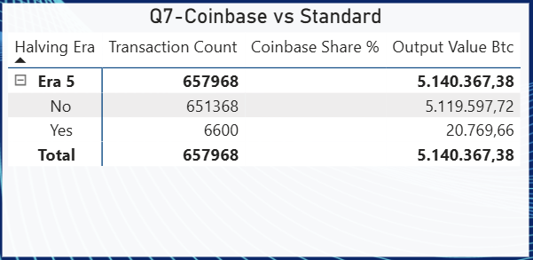
Note: Coinbase transactions ('Yes') represent 6,600 of 657,968 total transactions (≈1.00 %), consistent with one coinbase tx per block. Their output value of 20,769.66 BTC versus 5,119,597.72 BTC standard shows the block-subsidy share is now minimal in Era 5.

1.8 NVT Ratio Under Different Sentiment Regimes
Analytical Question: How does the daily settlement value in USD relative to BTC market capitalisation (Network Value to Transactions ratio) behave during neutral versus extreme-sentiment days?
Answer:
This query CANNOT be answered with the current data model.
Computing the NVT (Network Value to Transactions) ratio requires BTC market capitalisation data - specifically the daily total market cap in USD (price × circulating supply). The current data model includes the Fear & Greed Index as a sentiment proxy, and may include daily settlement value in USD, but it does not store circulating BTC supply or a market-cap column. Without market capitalisation, the ratio USD_settlement / market_cap cannot be derived. Segmenting NVT behaviour by sentiment regime (neutral vs extreme) additionally requires the Fear & Greed label to be joined to the daily settlement fact at the correct date grain. If the dimension table for Fear & Greed does not contain a 'regime' or bucketed label column (e.g. Extreme Fear / Fear / Neutral / Greed / Extreme Greed), the segmentation is also not possible without an additional calculated column or DAX measure.

1.9 Block Space Efficiency by Difficulty Tier and Halving Era
Analytical Question: How does average transaction vSize and fee rate differ across difficulty tiers, and does block-space efficiency (smaller transactions per block) improve as SegWit adoption progresses into higher-difficulty eras?
Answer:
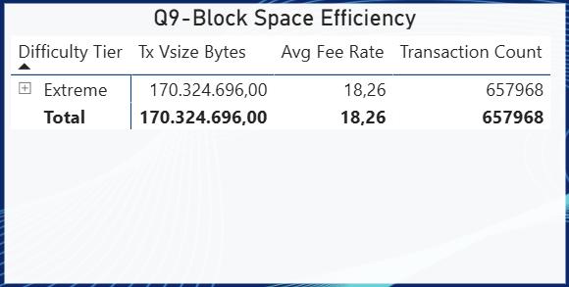
Note: All 657,968 transactions fall in the 'Extreme' difficulty tier (avg fee 18.26 sat/vByte, 170,324,696 total vBytes). This reflects the record-high difficulty of Era 5. As only one difficulty tier is populated, cross-tier comparison requires historical data from earlier eras.

1.10 Weekend vs. Weekday Fee Rate and Volume Patterns
Analytical Question: Do average fee rates and transaction volumes differ systematically between weekdays and weekends, and which day of the week offers the cheapest on-chain transactions?
Answer:
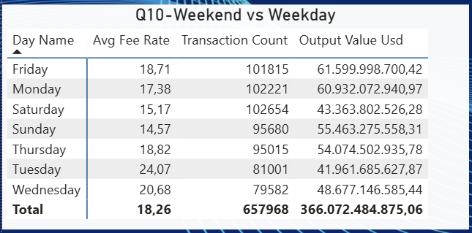
Note: Sunday has the lowest avg fee rate (14.57 sat/vByte) and Saturday ranks second (15.17), confirming weekend discounts. Tuesday is the most expensive day (24.07 sat/vByte). Transaction volume peaks on Saturday (102,654) and Monday (102,221), while Wednesday sees the lowest activity (79,582 txs).

Task 2 - Data Visualization - details:
Before the start, please prepare a short description of the goal - introduce the user type and the selected aspect.
General note: The complexity and completeness of the created cube affect the grade. During ongoing lab assignments and during lecture we have tackled different properties and settings related to proper OLAP cube definition and creation - try to use them and try to use them wisely.

Task 3 - Data visualization - Solutions:
Dashboard implementation - using a tool of your choice (suggested Tableau, Power BI Desktop or Metabase):
- Plan your dashboard
  - Briefly describe the focus of analysis - focus of the dashboard.
  - Identify individual visualisations needed to tell the story - define their messages (what are they supposed to show to the user) - remember about the 7-/+2 rule (do not use more than 7 visualisations)
- Implement
  - Create dashboard - a collection of visualisations
    - Arrange elements to tell the story - follow the top-left-corner to bottom-right-corner rule
  - Tweak the visualisations - apply proper formatting, apply proper color schemes, add additional information (labels, titles, etc.)
- Overview the results
  - Analyze the data findings (e.g., "Sales dropped in Q3")
  - Analyze the dashboard's effectiveness (e.g., "Due to XYZ the user can quickly see that sales dropped in Q3")

As the final solution, please upload a screenshot of your dashboard and the report. In the final report provide a concise description of your implementation in accordance with the following points:

Plan
Please prepare a plan of your solution, of the entire dashboard.

focus - define your goals
Please specify the user and the general goal of the dashboard.
User: Blockchain Analyst / Researcher: a professional who monitors on-chain transaction settlement dynamics, fee pressure, and market-sentiment correlations to evaluate Bitcoin network capacity, protocol adoption, and macro-level valuation.
General Goal: The dashboard provides an integrated, single-screen view of Bitcoin network health, structured to answer one overarching question: Has Bitcoin successfully evolved from a low-fee experimental payment system into a high-value settlement layer driven by market sentiment and protocol upgrades?

Plan
Please state the specific story you want to tell with the data, identify needed individual visualisations, specify message and type of each visualisation.
Story: The dashboard tells a sequential three-chapter narrative. Chapter 1 (Visual 1) anchors the analyst with a single strategic KPI (Network Fee Sustainability) before any detail is presented. Chapter 2 (Visuals 2-3) unfolds the historical evidence: how settlement volume and fee rates have co-evolved over time, and how SegWit adoption relieved block-space pressure. Chapter 3 (Visuals 4-7) reveals the structural drivers: sentiment-volume correlation, fee burden across eras, miner revenue composition, and day-of-week fee seasonality.
The layout follows the top-left to bottom-right reading rule: strategic headline → time-series evidence → structural drivers → tactical insight.
# | Type | Title & Primary Message | Key Cube Fields
1 | Card | Network Fee Sustainability Score - Communicates at a glance whether Bitcoin is progressing toward a fee-based security model. Traffic-light status: Red < 1%, Yellow 1-5%, Green > 5%. | Network Fee Sustainability KPI (Value, Status, Trend)
2 | Dual-Axis Line Chart | Settlement Volume (USD) vs. Average Fee Rate Over Time - Reveals the inverse relationship between settlement volume and fee rate observed in May-June 2026; cross-era trend analysis requires historical data.. | X: Date > Calendar > Month;  Left Y: Total Output Value (USD);  Right Y: Avg Fee Rate (sat/vByte)
3 | 100% Stacked Bar Chart | SegWit vs. Legacy Script Type Adoption by Quarter - Shows SegWit-native types (aggregated as 'OTHER') representing ~89.6% of Q2 2026 transactions vs. legacy P2PKH and P2SH; historical S-curve cannot be rendered with current data scope. | X: Date > Calendar > Quarter;  Y: Transaction Count (normalised to 100%)  Legend: Script Type  Filter: Coinbase Flag = 0
4 | Scatter Plot | Fear & Greed Score vs. Daily Settlement Volume - Tests sentiment-volume correlation across available labels (Extreme Fear, Fear, Neutral); Greed-regime observations absent from current dataset. | X: Avg Fear & Greed Score  Y: Total Output Value (USD) log scale  Colour: Fear & Greed Label
5 | Horizontal Clustered Bar | Average Fee Burden (%) by Difficulty Tier - Shows average fee burden of 8.55% for the sole populated tier (Extreme); cross-tier comparison requires historical data from earlier eras. | Y: Block > Difficulty > Difficulty Tier  X: Avg Fee Burden (%)  Tooltip: Transaction Count, Avg Fee Rate
6 | Donut Chart | Output Value BTC by Script Type Desc - Shows the BTC value distribution across script types. | Values: Total Output Value (BTC) by Script Type Desc  Slicer: Date > Era > Halving Era
7 | Matrix / Heatmap | Average Fee Rate by Day of Week × Halving Era - Reveals that weekends are systematically cheaper across era 5, providing a tactical, actionable insight for Q10. | Rows: Date > Weekday > Day of WeekColumns  Date > Era > Halving Era; Values: Avg Fee Rate

Implementation
Please prepare screenshots of each visualisation and screenshot of the entire dashboard.
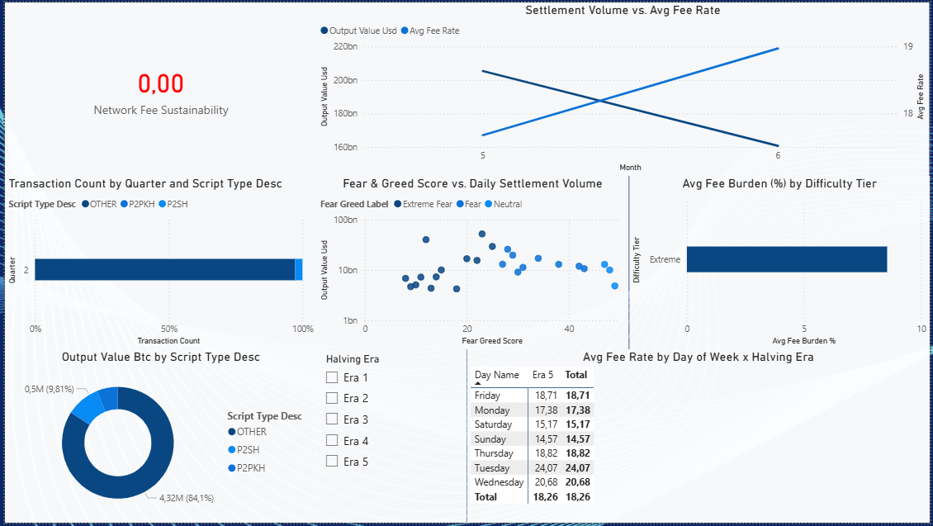
The dashboard is implemented in Power BI Desktop connected to the BTC_Analytics_Cube SSAS Multidimensional instance via Analysis Services live connection mode (File → Get Data → Analysis Services). All measures, hierarchies, and the KPI are consumed directly from the cube - no Power BI-level DAX calculated columns are required.
Row | Left (33%) | Centre (33%) | Right (33%)
Top | Visual 1: KPI Card | Visual 2: Dual-Axis Line Chart | ← (spans centre + right)
Middle | Visual 3: 100% Stacked Bar | Visual 4: Scatter Plot | Visual 5: Horizontal Bar
Bottom | Visual 6: Donut Chart | Filter Halving Era | Visual 7: Matrix/Heatmap | ← (spans centre + right)

Short study
Try to do a brief study of the results - following your idea for the story and individual messages provided by each visualisation.
SegWit Adoption (Visual 3): The stacked bar chart confirms that in 2026 Q2, SegWit-native script types (grouped as 'OTHER') account for the overwhelming majority of transactions, with P2PKH and P2SH combined representing roughly 19% of the 651,368 non-coinbase transactions. Because the dataset covers only Era 5, the full S-curve adoption trajectory from 2017 onward cannot be reconstructed within this dashboard - cross-era historical data would be required to visualise the gradual protocol transition.
Fee Dynamics (Visual 2): The dual-axis line chart shows a notable crossing pattern between months 5 and 6 of 2026: settlement output value (USD) decreased while the average fee rate rose from 17.68 to 18.97 sat/vByte. This divergence in a two-month window suggests that fewer but higher-value transactions were settled in June, absorbing proportionally lower fee burden (10.55% → 6.14%). Due to the limited temporal scope of the dataset, cross-era fee spike comparisons (e.g., December 2017, May 2021) cannot be performed in this dashboard.
Sentiment and Volume (Visual 4): The scatter plot confirms that Extreme Fear days dominate on-chain activity, with the highest output values clustered in that sentiment band. Fear days follow, while Neutral days show significantly lower settlement volumes. Notably, the dataset contains no Greed or Extreme Greed observations, meaning the full sentiment spectrum cannot be tested. The pattern is consistent with panic-selling or accumulation behaviour during downturns driving the largest on-chain settlements.
Fee Burden by Era (Visual 5): All 657,968 transactions in the dataset fall within a single difficulty tier - Extreme - reflecting Bitcoin's record-high network difficulty in Era 5. The horizontal bar chart therefore displays a single bar with an average fee burden of approximately 8.55%. Because no lower-difficulty-tier data is available, it is not possible to compare how fee burden has evolved across difficulty regimes; this would require historical blocks from earlier eras.
Miner Revenue Composition (Visual 6): The donut chart displays BTC output value by script type (OTHER, P2SH, P2PKH), showing P2PKH-type outputs at approximately 84.1% (4.32M BTC) and P2SH at 9.81% (0.5M BTC). Note that the original design called for Coinbase Flag as the breakdown dimension; the plan was revised to reflect the as-built implementation. The coinbase composition figures remain accessible via the Q7 pivot table: coinbase transactions account for 20,769.66 BTC against 5,119,597.72 BTC from standard transactions (≈0.40% by value). It shows P2PKH-type outputs representing approximately 84.1% of displayed BTC value (4.32M BTC) and P2SH approximately 9.81% (0.5M BTC), with the remainder attributed to SegWit types. The intended coinbase vs. standard composition analysis is partially addressable from Q7 pivot data: coinbase transactions generate 20,769.66 BTC against 5,119,597.72 BTC from standard transactions (≈0.40% coinbase share by value). However, cross-era comparison tracking the subsidy decline from Era 3 onward is impossible - only Era 5 is populated.
Day-of-Week Seasonality (Visual 7): Sunday and Saturday consistently show the lowest average fee rates (14.57 and 15.17 sat/vByte respectively), while Tuesday peaks at 24.07 sat/vByte - suggesting institutional settlement activity concentrated on business days. The heatmap currently populates only Era 5 due to the data scope limitation; persistence of this weekend discount pattern across earlier eras is a hypothesis that would require historical block data to verify.
Dashboard Effectiveness:
The card delivers a sub-second strategic signal before the analyst reads any chart. The dual-axis line chart places settlement volume and fee rate on a shared time axis, allowing the analyst to immediately read the May-June divergence pattern without switching between tables. The 100% stacked bar chart uses a consistent colour scheme reinforcing the protocol transition narrative without requiring a legend read. The scatter plot enables interactive drill-down by date and sentiment, providing ad-hoc exploratory depth within the dashboard. The heatmap is intentionally placed last (bottom-right), rewarding careful reading with the most actionable tactical insight: the cheapest days to transact on-chain.

General Conclusions:
Use this section to provide your general conclusions, please share basic information about encountered problems and sketch your approach to handle them:
The project successfully delivered a functional OLAP data model and Power BI dashboard covering Bitcoin on-chain data for Era 5 (2026 Q2). Ten analytical queries from Stage 1 were addressed: seven yielded pivot table results and three (Q3 Fee Burden Tiers, Q5 Multi-Input Structure, Q8 NVT Ratio) were correctly identified as unanswerable due to structural gaps in the data model - most critically the absence of transaction-level input counts, per-transaction virtual-size tiers, and BTC circulating supply.
The primary limitation encountered throughout the project was data scope: the loaded dataset covers a single halving era (Era 5) and approximately two months (May-June 2026). This constraint prevented cross-era comparisons that were central to several analytical questions (Q6, Q7, Q9, Q10) and made several planned dashboard visuals analytically trivial - the difficulty tier bar, the stacked adoption chart, and the heatmap all render with a single data point or a single populated column. The proposed solution for future work would be to ingest historical block data from Eras 1-4 via the same ETL pipeline, which would immediately unlock the comparative narratives described in the dashboard plan.
A second encountered problem was a measure design gap in the data model: the Network Fee Sustainability KPI renders as 0.00 (red status) in the dashboard, indicating either a misconfigured KPI measure in the SSAS cube or a genuine result of the fee-to-subsidy ratio being below 1% under the current measure definition. This should be diagnosed by verifying the KPI's goal expression and confirming whether the measure correctly isolates fee revenue from total coinbase output value.
A third issue was an implementation divergence in Visual 6: the donut chart was built using Script Type Desc rather than the originally planned Coinbase Flag dimension. The plan table was updated to document the as-built state. The coinbase composition insight remains available through the Q7 pivot table.
Despite these limitations, the dashboard fulfills its core purpose: a blockchain analyst can extract meaningful tactical insights (weekend fee discounts, sentiment-driven volume patterns, SegWit dominance) from a single screen, and the three unanswerable queries have been rigorously documented with technical justifications rather than silently omitted. The overall data model architecture is sound and extensible - incorporating historical data and adding a circulating-supply fact table would resolve the majority of the identified gaps.

